**Experiment No: 11**

**Title:** Case Study on Microsoft Azure

**Aim:** To perform case study on Microsoft Azure

**Case Study:**

**What Is Microsoft Azure?**

Microsoft Azure is a Microsoft cloud service provider that provides cloud computing services like computation, storage, security and many other domains. Microsoft is one of the global leaders when it comes to Cloud solutions and global cloud infrastructure. Microsoft Azure provides services in 60+ global regions and serves in 140 counties. It provides services in the form of Infrastructure as a service, Platform as a Service and Software as a service. It even provides serverless computing meaning, you just put your code and all your backend activities as managed by Microsoft Azure.

It easily integrates with Microsoft Products making it very popular using Microsoft products. This platform is now 10 years old and it picked up to compete with the best of the best.

**Benefits of Microsoft Azure**



Microsoft Azure may be considered second to Amazon Web Services in few features, but it has quite a few that make it stand tall on its own. Let us take a look at them, one by one

**On-Demand Scalability**

When we talk of Application Hosting, we can never be sure of how many resources are enough and how many are too much. This is the nature of businesses that rely on varying traffics. What is does is forces businesses to plan a lot and invest a lot of money doing it. Microsoft Azure helps you save all this effort.

Microsoft Azure ensures your applications and data is distributed well enough that means you never run short of Server space. It also means your applications do not run on a single server making them available even in dire situations. Since these resources are properly clustered out and they can scale at will and in no time, your applications function very differently then they would in an on-premise architecture.

**Cost Effective**

One of the major benefits with cloud service providers is the cut down of upfront costs. Since you can configure and scale at will, you are not required to invest heavily here. Microsoft Azure ensures small scale investment does not require upfront costs. Also when it comes to people who have signed up contracts, they get heavy discounts. It also offers to Pay as go, model, meaning you get cost-cutting in the right sense.

**Hybrid Environments**

They say cloud is not a one fit solution for all. It is true indeed because every business will have its own set of problems. And not all businesses will always be in a state where they can migrate to the cloud entirely. While other platforms suffer here, as people either have to migrate to those platforms or call it off totally, Microsoft Azure benefits with its Hybrid approach. Meaning, with Microsoft Azure you can build Hybrid infrastructures, where your resources can partially reside on the cloud and can partially operate from an on-premise infrastructure. Hence you are safe from costly workaround.

**Big data Applications**

Hadoop and Big data are the need of the hour. With data increasing exponentially we need applications that can help process this data. Microsoft Azure brings this capability of processing large volumes of data on top of its cloud platform. Azure HDinsight ensures you can use Apache Hadoop as a cloud solution. This is a power-packed service that lets you deal with large data volumes. That means your data crunching becomes easier.

It also readily integrates with data visualization tools and also lets you move your data to excel. This means your data visualization concerns are resolved quickly. With excel you can create visualizations and with PowerBI integrating with Microsoft Azure your data be converted into any visual that you require.

**Integration Capabilities**

Microsoft has been in the software industry for decades. It has wide reach in the software market and not many can compete with it when it comes to customer base and stack of products it offers. The advantage for Microsoft Azure here is that it readily integrates with most of these products. Be it, connecting to SaaS, PaaS, IaaS applications or even something like Visual Studio or Active Directory, Microsoft Azure has you covered. Hence you can now leverage ERPs and CRMs to enhance your business capacity to a greater level.

So should you be worrying if you do not use Microsoft Products. The answer is ‘NO’. You can even connect to or integrate many third-party applications and services to widen your business reach.

**Storage and Security**

Storage is very critical to any application. It is no different for applications running on cloud. As already discussed, the volume of data we handle these days is huge. It also comes in different formats and from different sources. Your Storage resources have to adept enough to handle this data. Microsoft Azure has you covered here as well It lets you store data in form of files, objects, structured and unstructured data and a lot more. This happens reliable and securely.

Talking of security Microsoft Azure ensures high level of security for your applications. It ensures all the resources in Azure cloud are guarded with firewalls and data is moved over the network with encryption. You have access to authentication and access management meaning you data and application are secure to the core.

**Scheduling and Automation**

Everyone hates doing repetitive tasks. What if we could automate mundane tasks or recurring tasks be it fetching some data, setting up triggers or scaling your resources when needed? Microsoft Azure does that for you ensuring you can utilise your workforce for more productive outcomes and get rid of stagnancy or repetition of work.

**Data Backup and Recovery**

Data Backup ensures you have a copy of your data maintained in case if your primary copy of data or resources is lost. With Microsoft Azure, you have an option of backing up your data in different Azure regions or data centres. You can maintain as many as six copies of your data. This signifies that the chance of losing your data on Microsoft Azure is minimal. When it comes to reliability your data is available 99.9 percent.

**Use Cases of Microsoft Azure**

**1)IoT Services**

The Internet of Things has a very different infrastructure than the technologies being used today. In order to enable IoT, companies need cloud services that can intelligently analyze and use sensor data and bind actions based on this sensor data. The internet of things is built on sensors; automation means that the devices need to be able to sense when they should perform a particular task.

Azure has a specialized set of IoT services bundles together to provide everything needed to power an IoT network.  This includes DocumentDB, Stream Analytics, HDInsight, and Event Hubs.

**2) Disaster Recovery**

Disaster recovery has always been a strong point of cloud services. Some of the first cloud customers were banks and financial institutions that needed to have access to their data no matter what disaster struck. Azure provides much better disaster recovery options than most of the alternatives. Azure keeps your data safe by making redundant copies in multiple locations. You can manually choose the locations of your database backups but even if you do not, Azure will manage the security by default.

**3) User Generated Content Hosting**

These days, content is king. User generated content is also notoriously hard to manage; it needs to be categorized, optimized, and processed quickly without needing the user to do anything. User generated content doesn’t just mean videos and pictures uploaded by the users, it also includes comments, reviews, shares, and anything else which users leave on websites. DocumentDB automatically indexes all the data it receives which makes it perfect for storing user generated content of all types.

**4) Feature Testing**

Azure offers fantastic virtual machine solutions for testing out new features. Almost every respectable cloud service provider allows you to create virtual machines or instances in order to test out features, but Azure is very different when it comes to paying for these virtual machines. Most bill by the hour, so even if you use a VM for only a few minutes your organization will end up paying for an hour’s worth of use. Azure bills you for exactly the time that you use the VMs for, which lowers costs substantially. Microsoft also has very powerful setups available for its virtual machines.

**5) Product Databases and Catalogs**

DocumentDB in Azure is a JSON store, which means it can easily and quickly work with several systems and store information and attributes easily. Azure is very powerful when it comes to complex databases. The more attributes and links there are between data, the more useful Azure will be for your organization. The database can be of products, IoT devices, or any object and Azure will be able to handle it with ease. Nested data and flexible schemas are built into DocumentDB which allows complex databases to work instantaneously.

Azure Blob Storage

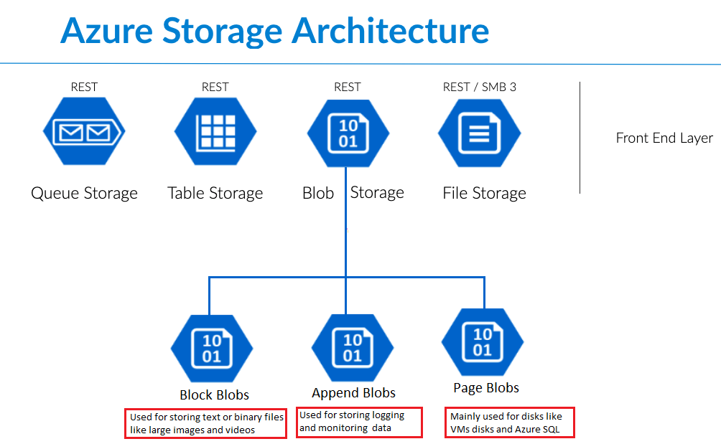

Azure Blob Storage is a cloud-based object storage service provided by Microsoft Azure. It is designed for storing and managing large amounts of unstructured data, such as documents, images, videos, and backups. Azure Blob Storage is part of the Azure Storage service and is highly scalable, durable, and cost-effective. Here are some key features and information about Azure Blob Storage:

1. Types of Blobs:

Azure Blob Storage offers three types of blobs, each tailored to specific use cases:

- Block Blobs: Block blobs are optimized for storing binary or text data, such as documents, images, and videos. They are highly efficient for uploading and appending data.

- Page Blobs: Page blobs are used primarily for VHD (Virtual Hard Disk) files associated with Azure Virtual Machines. They provide random access to data and are used for creating VM disk images.

- Append Blobs: Append blobs are designed for scenarios where data is continually appended, such as logging and telemetry data. They are optimized for write operations.

2. Scalability:

Azure Blob Storage is highly scalable, allowing you to store and manage vast amounts of data. You can easily scale your storage capacity up or down based on your needs. This makes it suitable for applications with fluctuating storage requirements.

3. Data Redundancy and Durability:

Azure Blob Storage provides built-in redundancy to ensure the durability of your data. It replicates data within the same data center or across multiple data centers in the same region, depending on your chosen redundancy level (e.g., Locally Redundant Storage, Geo-Redundant Storage).

4. Data Security:

You can control access to your blobs by using Azure's authentication and authorization mechanisms, such as shared access signatures (SAS), Azure Active Directory, and access control lists (ACLs). Additionally, Azure Blob Storage offers encryption at rest for data security.

5. Lifecycle Management:

Azure Blob Storage allows you to define data retention and lifecycle policies, making it easy to automatically delete or archive data based on predefined rules. This helps in managing data and controlling costs effectively.

6. Integration and Ecosystem:

Azure Blob Storage integrates seamlessly with other Azure services, making it a vital component for building cloud-native applications and services. It is often used in conjunction with services like Azure Functions, Azure Data Factory, and Azure Databricks.

7. Cost-Effective Storage:

Azure Blob Storage offers flexible pricing options, including pay-as-you-go pricing, making it cost-effective for a wide range of use cases. You only pay for the storage capacity you use, with options for hot and cool access tiers based on your data's access patterns.

8. Data Access and APIs:

Azure Blob Storage can be accessed through various programming languages and client libraries. It supports REST APIs, Azure SDKs, and tools like Azure Storage Explorer for easy data management and access.

9. Data Analytics:

Azure Blob Storage is often used as a data lake for storing and analyzing large volumes of unstructured data. You can process and analyze data directly in Azure or use tools like Azure HDInsight or Azure Data Lake Analytics for big data analytics.

10. Use Cases:

- Storing media files, including images, videos, and audio.

- Backup and disaster recovery solutions.

- Hosting static websites.

- Archiving and long-term data retention.

- Data lakes and big data analytics.

- IoT data storage.

- Application logs and telemetry data storage.

Azure Blob Storage is a versatile and powerful service that plays a crucial role in many Azure-based applications and data management scenarios, offering reliable and cost-effective storage for various types of data.

**Conclusion:**

Thus, I have studied case study on Microsoft Azure.